Coding Standards Document

Team: Orange Juice and the Cowboy Hats

1 Introduction 2

2 A Foolish Consistency is the Hobgoblin of Little Minds 2

3 Code Lay-out 2

3.1 Indentations 2

3.2 Tabs or Spaces? 5

3.3 Maximum Line Length 5

3.4 Should a Line Break Before or After a Binary Operator? 6

3.5 Blank Lines 6

3.6 Source File Encoding 6

3.7 Imports 7

3.8 Module Level Dunder Names 8

5 Whitespace in Expressions and Statements 9

5.1 Pet Peeves 9

5.2 Other Recommendations 9

6 When to Use Trailing Commas 9

7 Comments 10

7.1 Block Comments 11

7.2 Inline Comments 11

7.3 Documentation Strings 11

8 Naming Conventions 12

8.1 Overriding Principle 12

8.2 Descriptive: Naming Styles 12

8.3 Prescriptive : Naming Conventions 14

8.3.1 Names to Avoid 14

8.3.2 ASCII Compatibility 14

8.3.3 Package and Module Names 14

8.3.4 Class Names 14

8.3.5 Type Variable Names 15

8.3.6 Exception Names 15

8.3.7 Global Variable Names 15

8.3.8 Function and Variable Names 15

8.3.9 Function and Variable Arguments 15

8.3.10 Method Names and Instance Variables 16

8.3.11 Constants 16

8.3.12 Designing for Inheritance 16

8.4 Public and Internal Interfaces 18

9 Programming Conditions 19

9.1 Function Annotations 24

9.2 Variable Annotations 24

9.3 Exceptions Handling 26

9.3.1 Use Specific Exceptions 26

9.3.2 Implement Error Logging 26

9.3.3 Define Custom Exception Classes 27

9.3.4 Handle Exceptions Gracefully 28

**10 References 29**

11 Copyrights 30

# 1 Introduction

This document gives coding conventions for the Python code comprising the standard library in the main Python distribution. It will serve as reference for all code in our Train Control System coding project.

# 2 A Foolish Consistency is the Hobgoblin of Little Minds

A style guide is about consistency. Consistency with this style guide is important. Consistency within a project is more important. Consistency within one module or function is the most important.

However, sometimes style-guide recommendations just aren’t applicable. When in doubt, use your best judgment.

Some good reasons to ignore a style guide:

1. When applying the guideline would make the code less readable, even for someone who is used to reading code that follows this PEP.
2. To be consistent with surrounding code that also breaks it.

# 3 Code Lay-out

## 3.1 Indentations

Use 4 spaces per indentation level.

Continuation lines should align wrapped elements either vertically using Python’s implicit line joining inside parentheses, brackets and braces, or using a hanging indent [1]. When using a hanging indent the following should be considered; there should be no arguments on the first line and further indentation should be used to clearly distinguish itself as a continuation line:

*# Correct:*

*# Aligned with opening delimiter.*

foo = long_function_name(var_one, var_two,

var_three, var_four)

*# Add 4 spaces (an extra level of indentation) to distinguish arguments from the rest.*

def long_function_name(

var_one, var_two, var_three,

var_four):

print(var_one)

*# Hanging indents should add a level.*

foo = long_function_name(

var_one, var_two,

var_three, var_four)

*# Wrong:*

*# Arguments on first line forbidden when not using vertical alignment.*

foo = long_function_name(var_one, var_two,

var_three, var_four)

*# Further indentation required as indentation is not distinguishable.*

def long_function_name(

var_one, var_two, var_three,

var_four):

print(var_one)

The 4-space rule is optional for continuation lines.

Optional:

*# Hanging indents *may* be indented to other than 4 spaces.*

foo = long_function_name(

var_one, var_two,

var_three, var_four)

When the conditional part of an if-statement is long enough to require that it be written across multiple lines, it’s worth noting that the combination of a two character keyword (i.e. if), plus a single space, plus an opening parenthesis creates a natural 4-space indent for the subsequent lines of the multiline conditional. This can produce a visual conflict with the indented suite of code nested inside the if-statement, which would also naturally be indented to 4 spaces. This PEP takes no explicit position on how (or whether) to further visually distinguish such conditional lines from the nested suite inside the if-statement. Acceptable options in this situation include, but are not limited to:

*# No extra indentation.*

if (this_is_one_thing and

that_is_another_thing):

do_something()

*# Add a comment, which will provide some distinction in editors*

*# supporting syntax highlighting.*

if (this_is_one_thing and

that_is_another_thing):

*# Since both conditions are true, we can frobnicate.*

do_something()

*# Add some extra indentation on the conditional continuation line.*

if (this_is_one_thing

and that_is_another_thing):

do_something()

(Also see the discussion of whether to break before or after binary operators below.)

The closing brace/bracket/parenthesis on multiline constructs may either line up under the first non-whitespace character of the last line of list, as in:

my_list = [

1, 2, 3,

4, 5, 6,

]

result = some_function_that_takes_arguments(

'a', 'b', 'c',

'd', 'e', 'f',

)

or it may be lined up under the first character of the line that starts the multiline construct, as in:

my_list = [

1, 2, 3,

4, 5, 6,

]

result = some_function_that_takes_arguments(

'a', 'b', 'c',

'd', 'e', 'f',

)

## 3.2 Tabs or Spaces?

Spaces are the preferred indentation method.

Tabs should be used solely to remain consistent with code that is already indented with tabs.

Python disallows mixing tabs and spaces for indentation.

## 3.3 Maximum Line Length

Limit all lines to a maximum of 79 characters.

For flowing long blocks of text with fewer structural restrictions (docstrings or comments), the line length should be limited to 72 characters.

Limiting the required editor window width makes it possible to have several files open side by side, and works well when using code review tools that present the two versions in adjacent columns.

The default wrapping in most tools disrupts the visual structure of the code, making it more difficult to understand. The limits are chosen to avoid wrapping in editors with the window width set to 80, even if the tool places a marker glyph in the final column when wrapping lines. Some web based tools may not offer dynamic line wrapping at all.

Some teams strongly prefer a longer line length. For code maintained exclusively or primarily by a team that can reach agreement on this issue, it is okay to increase the line length limit up to 99 characters, provided that comments and docstrings are still wrapped at 72 characters.

The Python standard library is conservative and requires limiting lines to 79 characters (and docstrings/comments to 72).

The preferred way of wrapping long lines is by using Python’s implied line continuation inside parentheses, brackets and braces. Long lines can be broken over multiple lines by wrapping expressions in parentheses. These should be used in preference to using a backslash for line continuation.

Backslashes may still be appropriate at times. For example, long, multiple with-statements could not use implicit continuation before Python 3.10, so backslashes were acceptable for that case:

with open('/path/to/some/file/you/want/to/read') as file_1, \

open('/path/to/some/file/being/written', 'w') as file_2:

file_2.write(file_1.read())

(See the previous discussion on multiline if-statements for further thoughts on the indentation of such multiline with-statements.)

Another such case is with assert statements.

Make sure to indent the continued line appropriately.

## 3.4 Should a Line Break Before or After a Binary Operator?

For decades the recommended style was to break after binary operators. But this can hurt readability in two ways: the operators tend to get scattered across different columns on the screen, and each operator is moved away from its operand and onto the previous line. Here, the eye has to do extra work to tell which items are added and which are subtracted:

## 3.5 Blank Lines

*# Wrong:*

*# operators sit far away from their operands*

income = (gross_wages +

taxable_interest +

(dividends - qualified_dividends) -

ira_deduction -

student_loan_interest)

## 3.6 Source File Encoding

Code in the core Python distribution should always use UTF-8, and should not have an encoding declaration.

In the standard library, non-UTF-8 encodings should be used only for test purposes. Use non-ASCII characters sparingly, preferably only to denote places and human names. If using non-ASCII characters as data, avoid noisy Unicode characters like z̯̯͡a̧͎̺l̡͓̫g̹̲o̡̼̘ and byte order marks.

All identifiers in the Python standard library MUST use ASCII-only identifiers, and SHOULD use English words wherever feasible (in many cases, abbreviations and technical terms are used which aren’t English).

Open source projects with a global audience are encouraged to adopt a similar policy.

## 3.7 Imports

Imports should usually be on separate lines:  
*# Correct:*

import os

import sys

*# Wrong:*

import sys, os

It’s okay to say this though:  
*# Correct:*

from subprocess import Popen, PIPE

* Imports are always put at the top of the file, just after any module comments and docstrings, and before module globals and constants.  
  Imports should be grouped in the following order:
  1. Standard library imports.
  2. Related third party imports.
  3. Local application/library specific imports.
* You should put a blank line between each group of imports.

Absolute imports are recommended, as they are usually more readable and tend to be better behaved (or at least give better error messages) if the import system is incorrectly configured (such as when a directory inside a package ends up on sys.path):  
import mypkg.sibling

from mypkg import sibling

from mypkg.sibling import example

However, explicit relative imports are an acceptable alternative to absolute imports, especially when dealing with complex package layouts where using absolute imports would be unnecessarily verbose:  
from . import sibling

from .sibling import example

* Standard library code should avoid complex package layouts and always use absolute imports.

When importing a class from a class-containing module, it’s usually okay to spell this:  
from myclass import MyClass

from foo.bar.yourclass import YourClass

If this spelling causes local name clashes, then spell them explicitly:  
import myclass

import foo.bar.yourclass

* and use myclass.MyClass and foo.bar.yourclass.YourClass.
* Wildcard imports (from <module> import *) should be avoided, as they make it unclear which names are present in the namespace, confusing both readers and many automated tools. There is one defensible use case for a wildcard import, which is to republish an internal interface as part of a public API (for example, overwriting a pure Python implementation of an interface with the definitions from an optional accelerator module and exactly which definitions will be overwritten isn’t known in advance).  
  When republishing names this way, the guidelines below regarding public and internal interfaces still apply.

## 3.8 Module Level Dunder Names

Module level “dunders” (i.e. names with two leading and two trailing underscores) such as __all__, __author__, __version__, etc. should be placed after the module docstring but before any import statements *except* from __future__ imports. Python mandates that future-imports must appear in the module before any other code except docstrings:

*"""This is the example module.*

*This module does stuff.*

*"""*

from __future__ import barry_as_FLUFL

__all__ = ['a', 'b', 'c']

__version__ = '0.1'

__author__ = 'Cardinal Biggles'

import os

import sys

4 String Quotes

In Python, single-quoted strings and double-quoted strings are the same. This PEP does not make a recommendation for this. Pick a rule and stick to it. When a string contains single or double quote characters, however, use the other one to avoid backslashes in the string. It improves readability.

For triple-quoted strings, always use double quote characters to be consistent with the docstring convention in [PEP 257](https://peps.python.org/pep-0257/).

# 5 Whitespace in Expressions and Statements

This section as a whole will specify the formatting and code layout of all code written for this project. This will be the most important section for uniformity.

## 5.1 Pet Peeves

This section will specify the number of spaces used per indentation level, likely 4 spaces in line with python standards.

## 5.2 Other Recommendations

This section specifies that there will be one statement per line.

# 6 When to Use Trailing Commas

Trailing commas are usually optional, except they are mandatory when making a tuple of one element. For clarity, it is recommended to surround the latter in (technically redundant) parentheses:

*# Correct:*

FILES = ('setup.cfg',)

*# Wrong:*

FILES = 'setup.cfg',

When trailing commas are redundant, they are often helpful when a version control system is used, when a list of values, arguments or imported items is expected to be extended over time. The pattern is to put each value (etc.) on a line by itself, always adding a trailing comma, and add the close parenthesis/bracket/brace on the next line. However it does not make sense to have a trailing comma on the same line as the closing delimiter (except in the above case of singleton tuples):

*# Correct:*

FILES = [

'setup.cfg',

'tox.ini',

]

initialize(FILES,

error=True,

)

*# Wrong:*

FILES = ['setup.cfg', 'tox.ini',]

initialize(FILES, error=True,)

# 7 Comments

Comments that contradict the code are worse than no comments. Always make a priority of keeping the comments up-to-date when the code changes!

Comments should be complete sentences. The first word should be capitalized, unless it is an identifier that begins with a lower case letter (never alter the case of identifiers!).

Block comments generally consist of one or more paragraphs built out of complete sentences, with each sentence ending in a period.

You should use one or two spaces after a sentence-ending period in multi-sentence comments, except after the final sentence.

Ensure that your comments are clear and easily understandable to other speakers of the language you are writing in.

## 7.1 Block Comments

Block comments generally apply to some (or all) code that follows them, and are indented to the same level as that code. Each line of a block comment starts with a # and a single space (unless it is indented text inside the comment).

Paragraphs inside a block comment are separated by a line containing a single #.

## 7.2 Inline Comments

Use inline comments sparingly.

An inline comment is a comment on the same line as a statement. Inline comments should be separated by at least two spaces from the statement. They should start with a # and a single space.

Inline comments are unnecessary and in fact distracting if they state the obvious. Don’t do this:

x = x + 1 *# Increment x*

But sometimes, this is useful:

x = x + 1 *# Compensate for border*

## 7.3 Documentation Strings

Conventions for writing good documentation strings (a.k.a. “docstrings”) are immortalized in [PEP 257](https://peps.python.org/pep-0257/).

* Write docstrings for all public modules, functions, classes, and methods. Docstrings are not necessary for non-public methods, but you should have a comment that describes what the method does. This comment should appear after the def line.

[PEP 257](https://peps.python.org/pep-0257/) describes good docstring conventions. Note that most importantly, the """ that ends a multiline docstring should be on a line by itself:  
*"""Return a foobang*

*Optional plotz says to frobnicate the bizbaz first.*

*"""*

* For one liner docstrings, please keep the closing """ on the same line:  
  *"""Return an ex-parrot."""*

# 8 Naming Conventions

The naming conventions of Python’s library are a bit of a mess, so we’ll never get this completely consistent – nevertheless, here are the currently recommended naming standards. New modules and packages (including third party frameworks) should be written to these standards, but where an existing library has a different style, internal consistency is preferred.

## 8.1 Overriding Principle

Names that are visible to the user as public parts of the API should follow conventions that reflect usage rather than implementation.

## 8.2 Descriptive: Naming Styles

There are a lot of different naming styles. It helps to be able to recognize what naming style is being used, independently from what they are used for.

The following naming styles are commonly distinguished:

* b (single lowercase letter)
* B (single uppercase letter)
* lowercase
* lower_case_with_underscores
* UPPERCASE
* UPPER_CASE_WITH_UNDERSCORES
* CapitalizedWords (or CapWords, or CamelCase – so named because of the bumpy look of its letters [[4]](https://peps.python.org/pep-0008/#id8)). This is also sometimes known as StudlyCaps.  
  Note: When using acronyms in CapWords, capitalize all the letters of the acronym. Thus HTTPServerError is better than HttpServerError.
* mixedCase (differs from CapitalizedWords by initial lowercase character!)
* Capitalized_Words_With_Underscores (ugly!)

There’s also the style of using a short unique prefix to group related names together. This is not used much in Python, but it is mentioned for completeness. For example, the os.stat() function returns a tuple whose items traditionally have names like st_mode, st_size, st_mtime and so on. (This is done to emphasize the correspondence with the fields of the POSIX system call struct, which helps programmers familiar with that.)

The X11 library uses a leading X for all its public functions. In Python, this style is generally deemed unnecessary because attribute and method names are prefixed with an object, and function names are prefixed with a module name.

In addition, the following special forms using leading or trailing underscores are recognized (these can generally be combined with any case convention):

* _single_leading_underscore: weak “internal use” indicator. E.g. from M import * does not import objects whose names start with an underscore.

single_trailing_underscore_: used by convention to avoid conflicts with Python keyword, e.g. :  
tkinter.Toplevel(master, class_='ClassName')

* __double_leading_underscore: when naming a class attribute, invokes name mangling (inside class FooBar, __boo becomes _FooBar__boo; see below).
* __double_leading_and_trailing_underscore__: “magic” objects or attributes that live in user-controlled namespaces. E.g. __init__, __import__ or __file__. Never invent such names; only use them as documented.

## 8.3 Prescriptive : Naming Conventions

### 8.3.1 Names to Avoid

Never use the characters ‘l’ (lowercase letter el), ‘O’ (uppercase letter oh), or ‘I’ (uppercase letter eye) as single character variable names.

In some fonts, these characters are indistinguishable from the numerals one and zero. When tempted to use ‘l’, use ‘L’ instead.

### 8.3.2 ASCII Compatibility

Identifiers used in the standard library must be ASCII compatible as described in the [policy section](https://peps.python.org/pep-3131/#policy-specification) of [PEP 3131](https://peps.python.org/pep-3131/).

### 8.3.3 Package and Module Names

Modules should have short, all-lowercase names. Underscores can be used in the module name if it improves readability. Python packages should also have short, all-lowercase names, although the use of underscores is discouraged.

When an extension module written in C or C++ has an accompanying Python module that provides a higher level (e.g. more object oriented) interface, the C/C++ module has a leading underscore (e.g. _socket)

### 8.3.4 Class Names

Class names should normally use the CapWords convention.

The naming convention for functions may be used instead in cases where the interface is documented and used primarily as a callable.

Note that there is a separate convention for builtin names: most builtin names are single words (or two words run together), with the CapWords convention used only for exception names and builtin constants.

### 8.3.5 Type Variable Names

Names of type variables introduced in [PEP 484](https://peps.python.org/pep-0484/) should normally use CapWords preferring short names: T, AnyStr, Num. It is recommended to add suffixes _co or _contra to the variables used to declare covariant or contravariant behavior correspondingly:

from typing import TypeVar

VT_co = TypeVar('VT_co', covariant=True)

KT_contra = TypeVar('KT_contra', contravariant=True)

### 8.3.6 Exception Names

Because exceptions should be classes, the class naming convention applies here. However, you should use the suffix “Error” on your exception names (if the exception actually is an error).

### 8.3.7 Global Variable Names

Let’s hope that these variables are meant for use inside one module only.) The conventions are about the same as those for functions.

Modules that are designed for use via from M import * should use the __all__ mechanism to prevent exporting globals, or use the older convention of prefixing such globals with an underscore (which you might want to do to indicate these globals are “module non-public”).

### 8.3.8 Function and Variable Names

Function names should be lowercase, with words separated by underscores as necessary to improve readability.

Variable names follow the same convention as function names.

mixedCase is allowed only in contexts where that’s already the prevailing style (e.g. threading.py), to retain backwards compatibility.

### 8.3.9 Function and Variable Arguments

Always use self for the first argument to instance methods.

Always use cls for the first argument to class methods.

If a function argument’s name clashes with a reserved keyword, it is generally better to append a single trailing underscore rather than use an abbreviation or spelling corruption. Thus class_ is better than clss. (Perhaps better is to avoid such clashes by using a synonym.)

### 8.3.10 Method Names and Instance Variables

Use the function naming rules: lowercase with words separated by underscores as necessary to improve readability.

Use one leading underscore only for non-public methods and instance variables.

To avoid name clashes with subclasses, use two leading underscores to invoke Python’s name mangling rules.

Python mangles these names with the class name: if class Foo has an attribute named __a, it cannot be accessed by Foo.__a. (An insistent user could still gain access by calling Foo._Foo__a.) Generally, double leading underscores should be used only to avoid name conflicts with attributes in classes designed to be subclassed.

Note: there is some controversy about the use of __names (see below).

### 8.3.11 Constants

Constants are usually defined on a module level and written in all capital letters with underscores separating words. Examples include MAX_OVERFLOW and TOTAL

### 8.3.12 Designing for Inheritance

Always decide whether a class’s methods and instance variables (collectively: “attributes”) should be public or non-public. If in doubt, choose non-public; it’s easier to make it public later than to make a public attribute non-public.

Public attributes are those that you expect unrelated clients of your class to use, with your commitment to avoid backwards incompatible changes. Non-public attributes are those that are not intended to be used by third parties; you make no guarantees that non-public attributes won’t change or even be removed.

We don’t use the term “private” here, since no attribute is really private in Python (without a generally unnecessary amount of work).

Another category of attributes are those that are part of the “subclass API” (often called “protected” in other languages). Some classes are designed to be inherited from, either to extend or modify aspects of the class’s behavior. When designing such a class, take care to make explicit decisions about which attributes are public, which are part of the subclass API, and which are truly only to be used by your base class.

With this in mind, here are the Pythonic guidelines:

* Public attributes should have no leading underscores.
* If your public attribute name collides with a reserved keyword, append a single trailing underscore to your attribute name. This is preferable to an abbreviation or corrupted spelling. (However, notwithstanding this rule, ‘cls’ is the preferred spelling for any variable or argument which is known to be a class, especially the first argument to a class method.)  
  Note 1: See the argument name recommendation above for class methods.
  + - For simple public data attributes, it is best to expose just the attribute name, without complicated accessor/mutator methods. Keep in mind that Python provides an easy path to future enhancement, should you find that a simple data attribute needs to grow functional behavior. In that case, use properties to hide functional implementation behind simple data attribute access syntax.  
      Note 1: Try to keep the functional behavior side-effect free, although side-effects such as caching are generally fine.  
      Note 2: Avoid using properties for computationally expensive operations; the attribute notation makes the caller believe that access is (relatively) cheap.
    - If your class is intended to be subclassed, and you have attributes that you do not want subclasses to use, consider naming them with double leading underscores and no trailing underscores. This invokes Python’s name mangling algorithm, where the name of the class is mangled into the attribute name. This helps avoid attribute name collisions should subclasses inadvertently contain attributes with the same name.  
      Note 1: Note that only the simple class name is used in the mangled name, so if a subclass chooses both the same class name and attribute name, you can still get name collisions.  
      Note 2: Name mangling can make certain uses, such as debugging and __getattr__(), less convenient. However the name mangling algorithm is well documented and easy to perform manually.  
      Note 3: Not everyone likes name mangling. Try to balance the need to avoid accidental name clashes with potential use by advanced callers.

## 8.4 Public and Internal Interfaces

Any backwards compatibility guarantees apply only to public interfaces. Accordingly, it is important that users be able to clearly distinguish between public and internal interfaces.

Documented interfaces are considered public, unless the documentation explicitly declares them to be provisional or internal interfaces exempt from the usual backwards compatibility guarantees. All undocumented interfaces should be assumed to be internal.

To better support introspection, modules should explicitly declare the names in their public API using the __all__ attribute. Setting __all__ to an empty list indicates that the module has no public API.

Even with __all__ set appropriately, internal interfaces (packages, modules, classes, functions, attributes or other names) should still be prefixed with a single leading underscore.

An interface is also considered internal if any containing namespace (package, module or class) is considered internal.

Imported names should always be considered an implementation detail. Other modules must not rely on indirect access to such imported names unless they are an explicitly documented part of the containing module’s API, such as os.path or a package’s __init__ module that exposes functionality from submodules.

# 9 Programming Conditions

Code should be written in a way that does not disadvantage other implementations of Python (PyPy, Jython, IronPython, Cython, Psyco, and such).  
For example, do not rely on CPython’s efficient implementation of in-place string concatenation for statements in the form a += b or a = a + b. This optimization is fragile even in CPython (it only works for some types) and isn’t present at all in implementations that don’t use refcounting. In performance sensitive parts of the library, the ''.join() form should be used instead. This will ensure that concatenation occurs in linear time across various implementations.

* Comparisons to singletons like None should always be done with is or is not, never the equality operators.  
  Also, beware of writing if x when you really mean if x is not None – e.g. when testing whether a variable or argument that defaults to None was set to some other value. The other value might have a type (such as a container) that could be false in a boolean context!

Use is not operator rather than not ... is. While both expressions are functionally identical, the former is more readable and preferred:  
*# Correct:*

if foo is not None:

*# Wrong:*

if not foo is None:

* When implementing ordering operations with rich comparisons, it is best to implement all six operations (__eq__, __ne__, __lt__, __le__, __gt__, __ge__) rather than relying on other code to only exercise a particular comparison.  
  To minimize the effort involved, the functools.total_ordering() decorator provides a tool to generate missing comparison methods.  
  [PEP 207](https://peps.python.org/pep-0207/) indicates that reflexivity rules *are* assumed by Python. Thus, the interpreter may swap y > x with x < y, y >= x with x <= y, and may swap the arguments of x == y and x != y. The sort() and min() operations are guaranteed to use the < operator and the max() function uses the > operator. However, it is best to implement all six operations so that confusion doesn’t arise in other contexts.

Always use a def statement instead of an assignment statement that binds a lambda expression directly to an identifier:  
*# Correct:*

def f(x): return 2*x

*# Wrong:*

f = lambda x: 2*x

* The first form means that the name of the resulting function object is specifically ‘f’ instead of the generic ‘<lambda>’. This is more useful for tracebacks and string representations in general. The use of the assignment statement eliminates the sole benefit a lambda expression can offer over an explicit def statement (i.e. that it can be embedded inside a larger expression)
* Derive exceptions from Exception rather than BaseException. Direct inheritance from BaseException is reserved for exceptions where catching them is almost always the wrong thing to do.  
  Design exception hierarchies based on the distinctions that code *catching* the exceptions is likely to need, rather than the locations where the exceptions are raised. Aim to answer the question “What went wrong?” programmatically, rather than only stating that “A problem occurred” (see [PEP 3151](https://peps.python.org/pep-3151/) for an example of this lesson being learned for the builtin exception hierarchy)  
  Class naming conventions apply here, although you should add the suffix “Error” to your exception classes if the exception is an error. Non-error exceptions that are used for non-local flow control or other forms of signaling need no special suffix.
* Use exception chaining appropriately. raise X from Y should be used to indicate explicit replacement without losing the original traceback.  
  When deliberately replacing an inner exception (using raise X from None), ensure that relevant details are transferred to the new exception (such as preserving the attribute name when converting KeyError to AttributeError, or embedding the text of the original exception in the new exception message).

When catching exceptions, mention specific exceptions whenever possible instead of using a bare except: clause:  
try:

import platform_specific_module

except ImportError:

platform_specific_module = None

* A bare except: clause will catch SystemExit and KeyboardInterrupt exceptions, making it harder to interrupt a program with Control-C, and can disguise other problems. If you want to catch all exceptions that signal program errors, use except Exception: (bare except is equivalent to except BaseException:).  
  A good rule of thumb is to limit use of bare ‘except’ clauses to two cases:
  1. If the exception handler will be printing out or logging the traceback; at least the user will be aware that an error has occurred.
  2. If the code needs to do some cleanup work, but then lets the exception propagate upwards with raise. try...finally can be a better way to handle this case.
* When catching operating system errors, prefer the explicit exception hierarchy introduced in Python 3.3 over introspection of errno values.

Additionally, for all try/except clauses, limit the try clause to the absolute minimum amount of code necessary. Again, this avoids masking bugs:  
*# Correct:*

try:

value = collection[key]

except KeyError:

return key_not_found(key)

else:

return handle_value(value)

*# Wrong:*

try:

*# Too broad!*

return handle_value(collection[key])

except KeyError:

*# Will also catch KeyError raised by handle_value()*

return key_not_found(key)

* When a resource is local to a particular section of code, use a with statement to ensure it is cleaned up promptly and reliably after use. A try/finally statement is also acceptable.

Context managers should be invoked through separate functions or methods whenever they do something other than acquire and release resources:  
*# Correct:*

with conn.begin_transaction():

do_stuff_in_transaction(conn)

*# Wrong:*

with conn:

do_stuff_in_transaction(conn)

* The latter example doesn’t provide any information to indicate that the __enter__ and __exit__ methods are doing something other than closing the connection after a transaction. Being explicit is important in this case.

Be consistent in return statements. Either all return statements in a function should return an expression, or none of them should. If any return statement returns an expression, any return statements where no value is returned should explicitly state this as return None, and an explicit return statement should be present at the end of the function (if reachable):  
*# Correct:*

def foo(x):

if x >= 0:

return math.sqrt(x)

else:

return None

def bar(x):

if x < 0:

return None

return math.sqrt(x)

*# Wrong:*

def foo(x):

if x >= 0:

return math.sqrt(x)

def bar(x):

if x < 0:

return

return math.sqrt(x)

Use ''.startswith() and ''.endswith() instead of string slicing to check for prefixes or suffixes.  
startswith() and endswith() are cleaner and less error prone:  
*# Correct:*

if foo.startswith('bar'):

*# Wrong:*

if foo[:3] == 'bar':

Object type comparisons should always use isinstance() instead of comparing types directly:  
*# Correct:*

if isinstance(obj, int):

*# Wrong:*

if type(obj) is type(1):

For sequences, (strings, lists, tuples), use the fact that empty sequences are false:  
*# Correct:*

if not seq:

if seq:

*# Wrong:*

if len(seq):

if not len(seq):

* Don’t write string literals that rely on significant trailing whitespace. Such trailing whitespace is visually indistinguishable and some editors (or more recently, reindent.py) will trim them.

Don’t compare boolean values to True or False using ==:  
*# Correct:*

if greeting:

*# Wrong:*

if greeting == True:

Worse:  
*# Wrong:*

if greeting is True:

Use of the flow control statements return/break/continue within the finally suite of a try...finally, where the flow control statement would jump outside the finally suite, is discouraged. This is because such statements will implicitly cancel any active exception that is propagating through the finally suite:  
*# Wrong:*

def foo():

try:

1 / 0

finally:

return 42

### 9.1 [Function Annotations](https://peps.python.org/pep-0008/#function-annotations)

With the acceptance of [PEP 484](https://peps.python.org/pep-0484/), the style rules for function annotations have changed.

* Function annotations should use [PEP 484](https://peps.python.org/pep-0484/) syntax (there are some formatting recommendations for annotations in the previous section).
* The experimentation with annotation styles that was recommended previously in this PEP is no longer encouraged.
* However, outside the stdlib, experiments within the rules of [PEP 484](https://peps.python.org/pep-0484/) are now encouraged. For example, marking up a large third party library or application with [PEP 484](https://peps.python.org/pep-0484/) style type annotations, reviewing how easy it was to add those annotations, and observing whether their presence increases code understandability.
* The Python standard library should be conservative in adopting such annotations, but their use is allowed for new code and for big refactorings.

For code that wants to make a different use of function annotations it is recommended to put a comment of the form:  
*# type: ignore*

* near the top of the file; this tells type checkers to ignore all annotations. (More fine-grained ways of disabling complaints from type checkers can be found in [PEP 484](https://peps.python.org/pep-0484/).)
* Like linters, type checkers are optional, separate tools. Python interpreters by default should not issue any messages due to type checking and should not alter their behavior based on annotations.
* Users who don’t want to use type checkers are free to ignore them. However, it is expected that users of third party library packages may want to run type checkers over those packages. For this purpose [PEP 484](https://peps.python.org/pep-0484/) recommends the use of stub files: .pyi files that are read by the type checker in preference of the corresponding .py files. Stub files can be distributed with a library, or separately (with the library author’s permission) through the typeshed repo [[5]](https://peps.python.org/pep-0008/#id9).

### 9.2 [Variable Annotations](https://peps.python.org/pep-0008/#variable-annotations)

[PEP 526](https://peps.python.org/pep-0526/) introduced variable annotations. The style recommendations for them are similar to those on function annotations described above:

* Annotations for module level variables, class and instance variables, and local variables should have a single space after the colon.
* There should be no space before the colon.

If an assignment has a right hand side, then the equality sign should have exactly one space on both sides:  
*# Correct:*

code: int

class Point:

coords: Tuple[int, int]

label: str = '<unknown>'

*# Wrong:*

code:int *# No space after colon*

code : int *# Space before colon*

class Test:

result: int=0 *# No spaces around equality sign*

* Although the [PEP 526](https://peps.python.org/pep-0526/) is accepted for Python 3.6, the variable annotation syntax is the preferred syntax for stub files on all versions of Python (see [PEP 484](https://peps.python.org/pep-0484/) for details).

Footnotes

[[1](https://peps.python.org/pep-0008/#id2)]

*Hanging indentation* is a type-setting style where all the lines in a paragraph are indented except the first line. In the context of Python, the term is used to describe a style where the opening parenthesis of a parenthesized statement is the last non-whitespace character of the line, with subsequent lines being indented until the closing parenthesis.

### 9.3 [Exceptions Handling](https://medium.com/@saadjamilakhtar/5-best-practices-for-python-exception-handling-5e54b876a20')

Exception handling is a fundamental aspect of writing robust and reliable Python code. Just like how a skilled driver navigates through unexpected roadblocks, a proficient programmer gracefully handles exceptions to maintain application stability and provide users with meaningful feedback. In this blog post, we’ll explore the best practices and guidelines for effective exception handling in Python. By following these strategies, you’ll be well-equipped to enhance your code’s resilience and provide a smoother user experience.

#### 9.3.1 Use Specific Exceptions

Catching specific exceptions is akin to using specialized tools for different tasks. Instead of relying on a generic catch-all statement, it’s essential to catch specific exception types. This practice allows you to differentiate between various errors and deliver accurate error messages, making issue identification and resolution more efficient.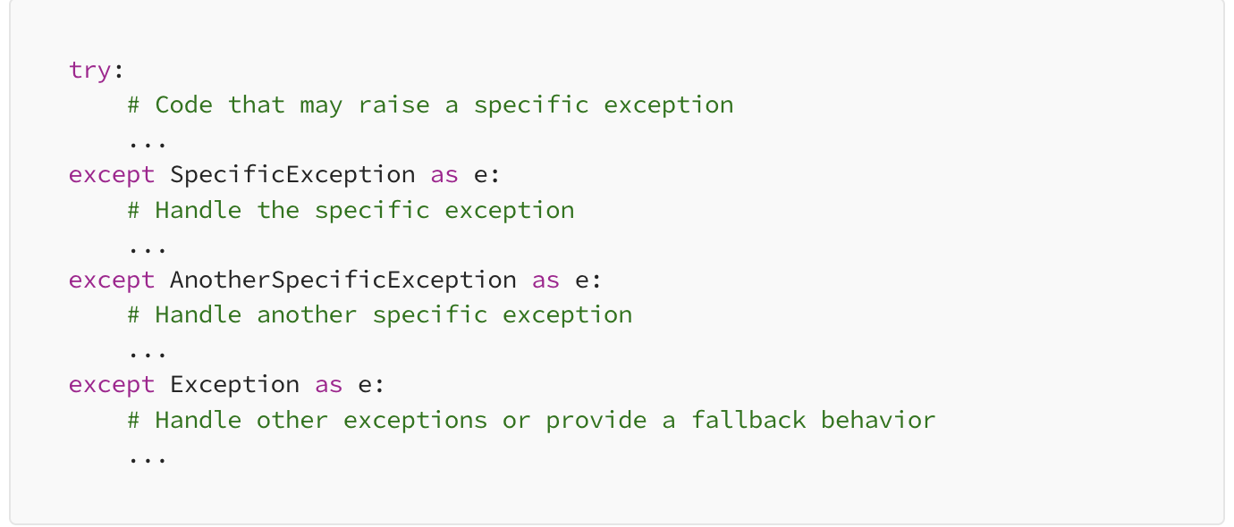

#### 9.3.2 Implement Error Logging

Imagine your Python application as a complex puzzle. Error logging acts as your cheat sheet, helping you put the pieces together when things go awry. Utilizing the logging module, you can capture exceptions along with vital information like timestamps, error details, and stack traces. This empowers you to analyze errors comprehensively and enhance the reliability of your application.

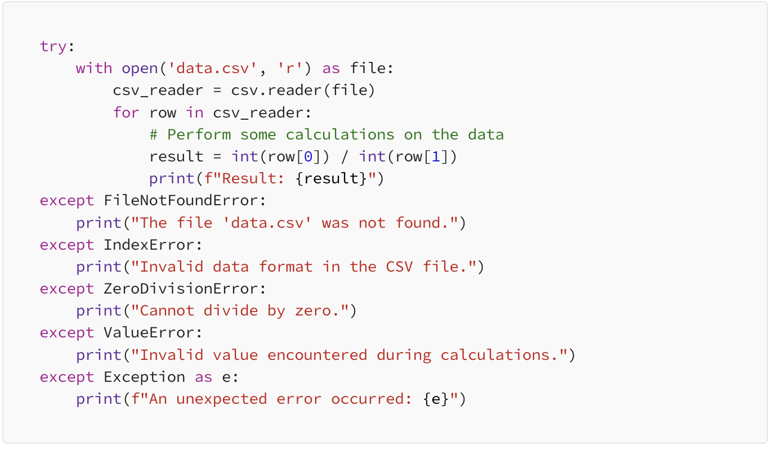

#### 9.3.3 Define Custom Exception Classes

Think of custom exception classes as tailored outfits for specific occasions. Python allows you to create custom exception classes that cater to your application’s unique needs. By doing so, you can categorize and encapsulate different errors, leading to better code readability, improved error handling, and modular project development.

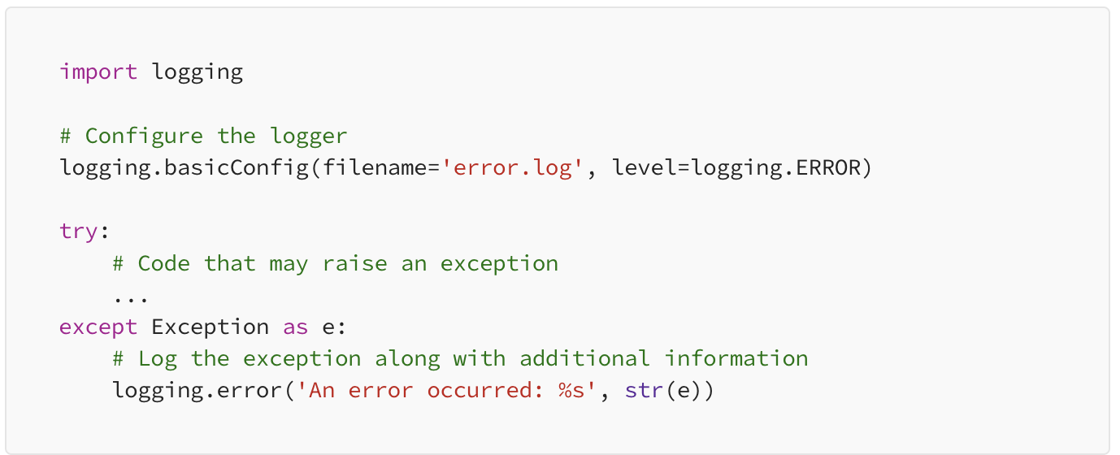

#### 9.3.4 Handle Exceptions Gracefully

Handling exceptions gracefully is like being a composed host at a dinner party when unexpected guests arrive. To prevent application crashes and user confusion, employ try-except blocks to catch exceptions. This allows you to provide suitable error messages or alternative actions. Graceful error handling enhances user experience, maintains application flow, and safeguards against security vulnerabilities

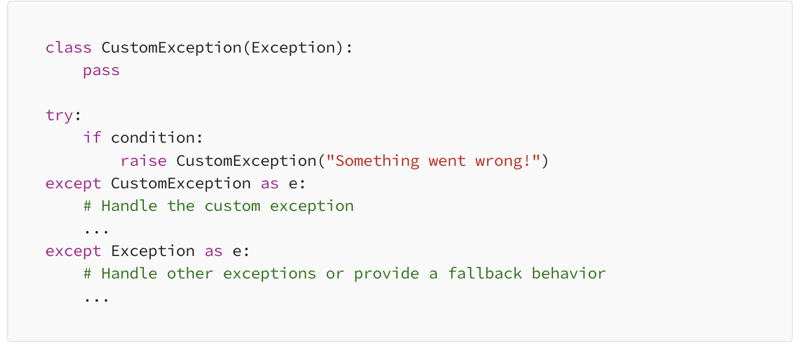

#### 9.3.5 Use Finally for Cleanup Tasks

Imagine you’re a responsible party host cleaning up after the festivities. The finally block in exception handling serves a similar purpose. It ensures that certain code will execute regardless of whether an exception occurred or not. This is ideal for performing cleanup tasks, such as closing files or releasing resources, maintaining your application’s integrity.

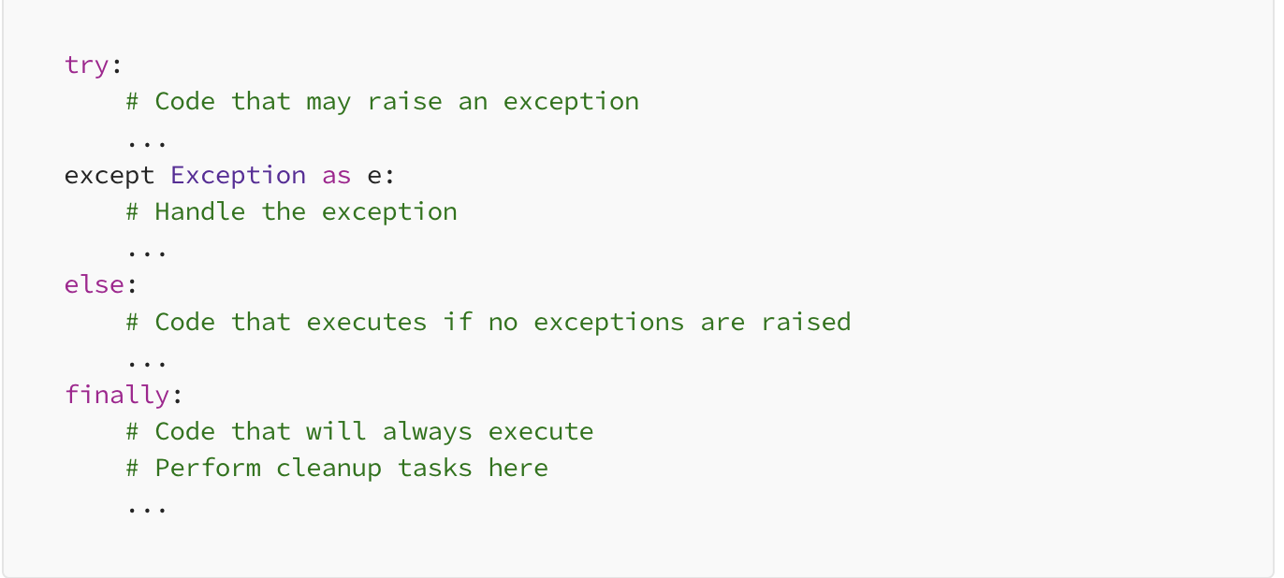

Mastering Python exception handling is a vital skill for any programmer. By integrating these best practices into your coding arsenal, you’re building a solid foundation for writing reliable, maintainable, and user-friendly code. Remember to catch specific exceptions, implement error logging, define custom exception classes, handle exceptions gracefully, utilize the else statement for clean execution paths, and employ the finally block for essential cleanup tasks. With these strategies, you’ll be well-prepared to navigate the challenges of error handling in Python and provide a seamless experience for

# 10 References

[[2](https://peps.python.org/pep-0008/#id1)]

Barry’s GNU Mailman style guide <http://barry.warsaw.us/software/STYLEGUIDE.txt>

[[3](https://peps.python.org/pep-0008/#id3)]

Donald Knuth’s *The TeXBook*, pages 195 and 196.

[[4](https://peps.python.org/pep-0008/#id4)]

<http://www.wikipedia.com/wiki/CamelCase>

[[5](https://peps.python.org/pep-0008/#id5)]

Typeshed repo <https://github.com/python/typeshed>

<https://peps.python.org/pep-0008/>

<https://google.github.io/styleguide/javaguide.html#s3.4-class-declaration>

<https://medium.com/@saadjamilakhtar/5-best-practices-for-python-exception-handling-5e54b876a20>

# 11 Copyrights

This document has been placed in the public domain.

Source: <https://github.com/python/peps/blob/main/peps/pep-0008.rst>

Last modified: [2023-12-09 16:19:37 GMT](https://github.com/python/peps/commits/main/pep-0008.rst)

# 